NAME : NARIGE ROHITH
ENROLL NO : 2503A54101
BATCH NO : 04
ASSIGNMENT : 2.2

**Task Description#1
- Use Gemini in Colab to write a function that filters out all negative numbers from a given list.

Expected Output#1
Functional code with before/after input and output shown in Colab, plus a screenshot.

*prompt:

Write a python function to filters out all negative numbers from a given list.

CODE :

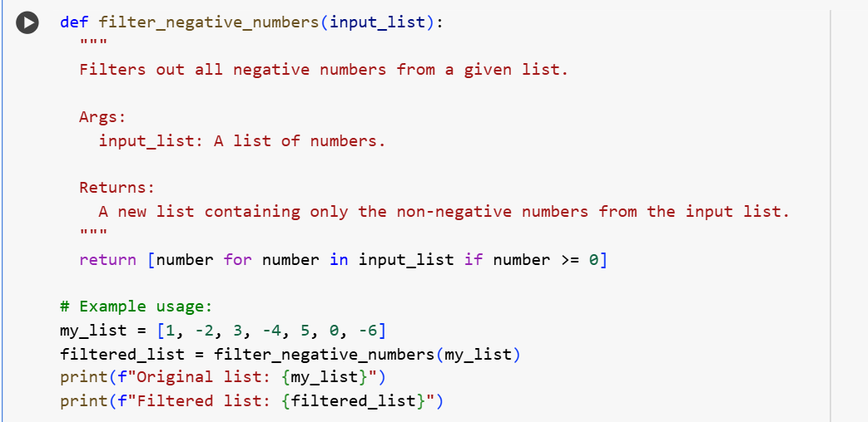

OUTPUT :

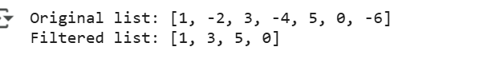

EXPLANATION :

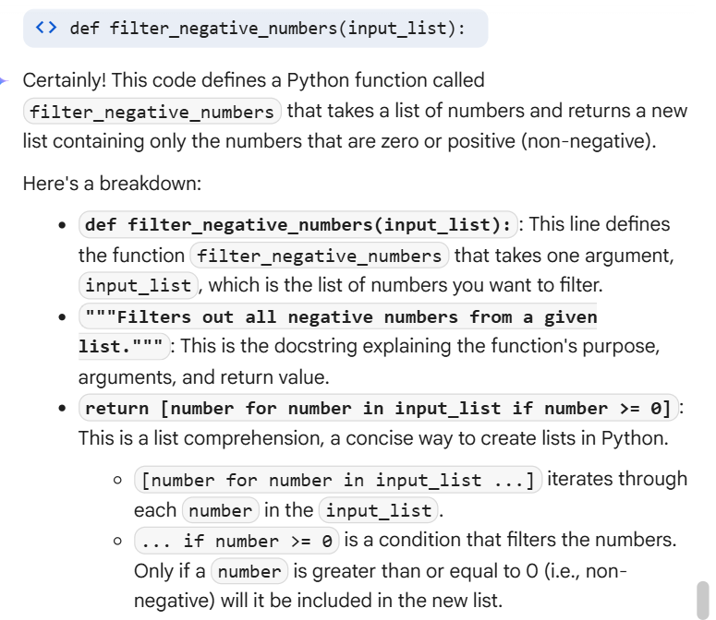

Task Description#2
- Ask Gemini to generate code that reads a text file and counts the frequency of each word. Then ask it to explain the code

Expected Output#2
- Working code and Gemini’s explanation side-by-side.

*prompt :

Write a python programme to read the code that reads a text file and that also counts frequency of each word.

CODE :

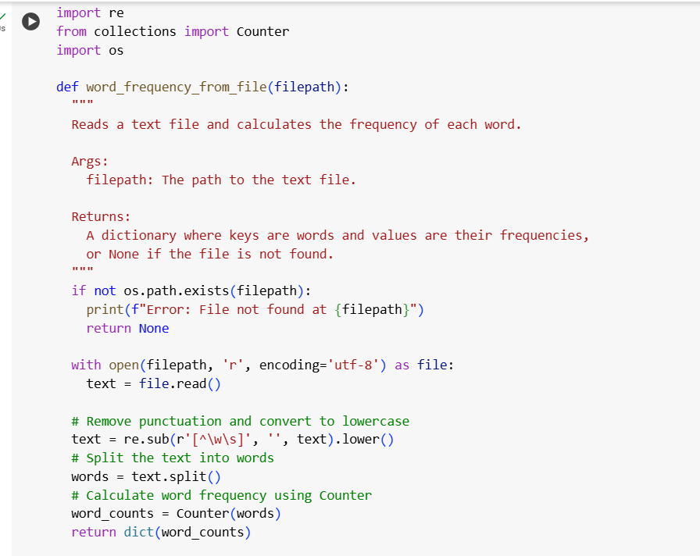
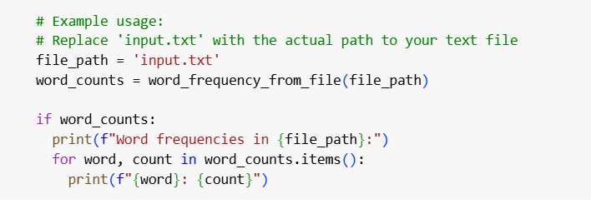

OUTPUT :

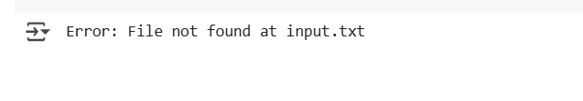
EXPLANATION :

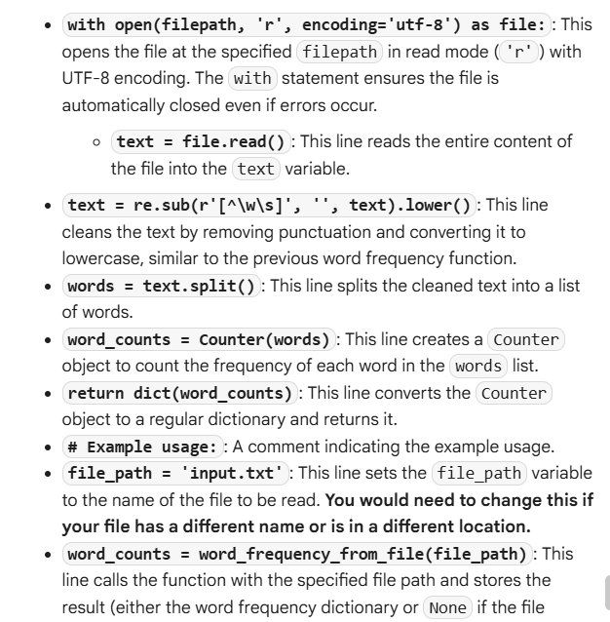

**Task Description#3

- Use Cursor AI to generate a Python class called Book with attributes title, author, and a method summary() that prints the details

Expected Output#3
Screenshot comparisons and student commentary on code clarity and performance

PROMPT :

Writw a python programme to generate a python class called book with attributes title, author, print the details.

CODE :

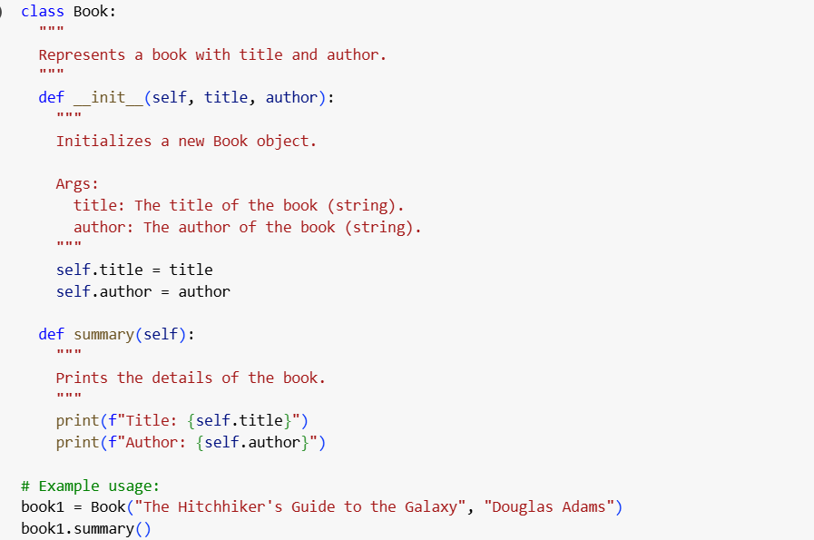

OUTPUT :

EXPLANATION :

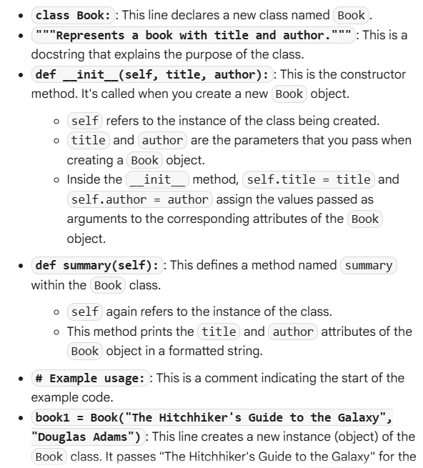

**Task Description#4

- Ask Gemini to write a program that checks whether a number is an Armstrong number, and then modify it using Cursor AI to improve performance or structure.

Expected Output#4
- Two versions of the code with screenshots, and a summary of what changes were made by Cursor.

PROMPT :

WRITE A PYTHON PROGRAMME TO CHECK A NUMBER WHETHER IT IS ARMSTRONG OR NOT’

EXPLANATION :

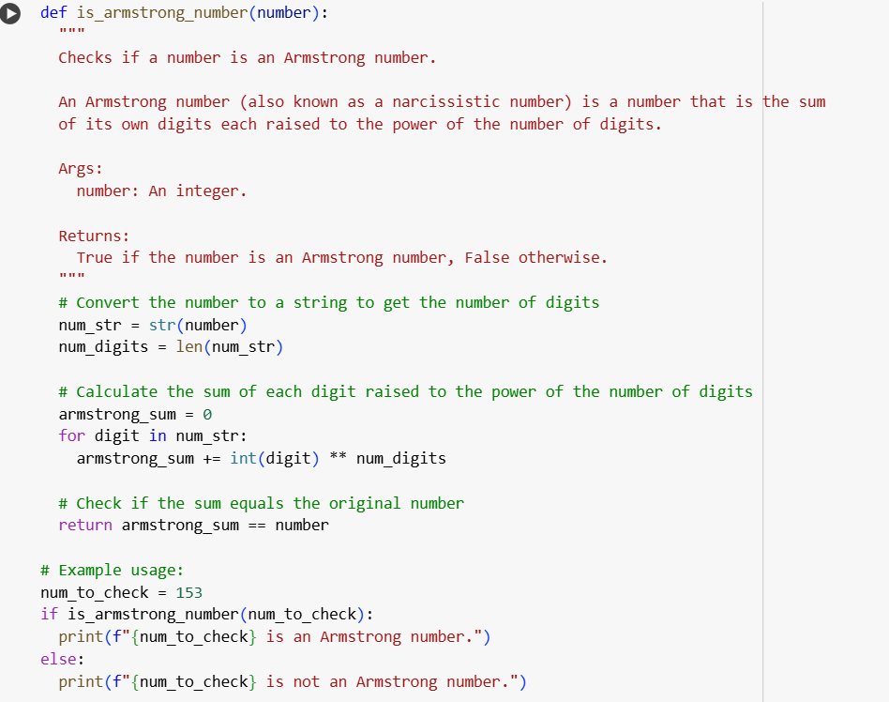

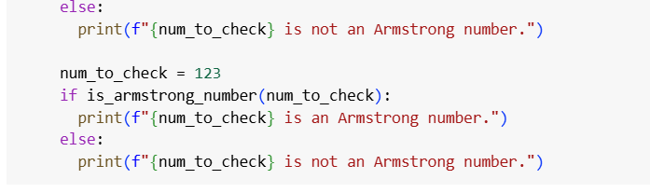

OUTPUT : 

EXPLANATION :

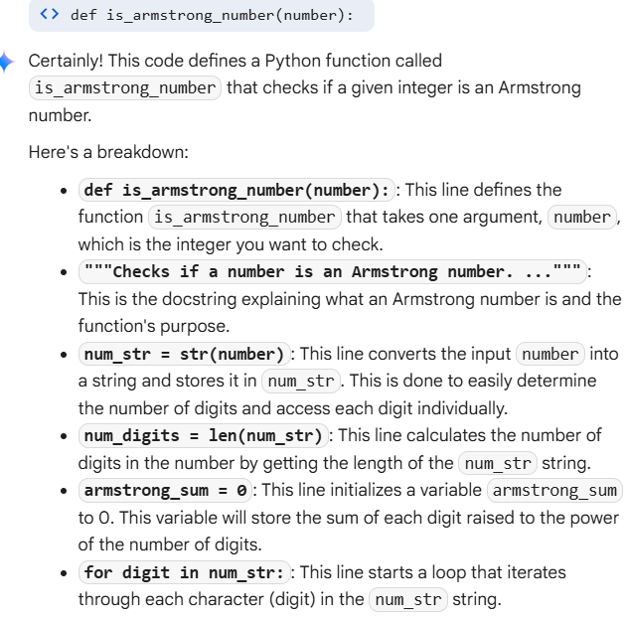

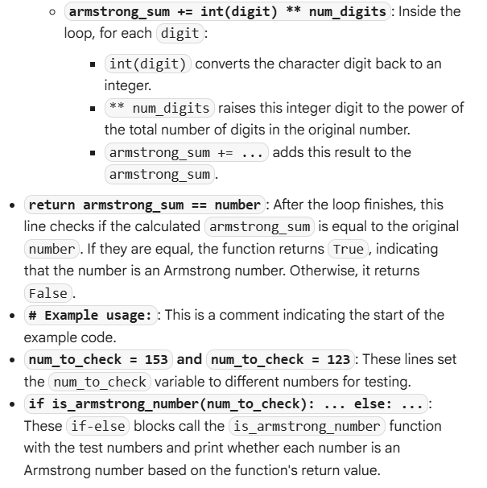

**Task Description#5
- Use both Gemini and Cursor AI to generate code for sorting a list of dictionaries by a specific key (e.g., age).

Expected Output#5
Screenshot comparisons and student commentary on code clarity and performancE

PROMPT :

WRITE A PYTHON PROGRAMME FOR SORTING A DICTIONARY (AGE)

CODE ;:

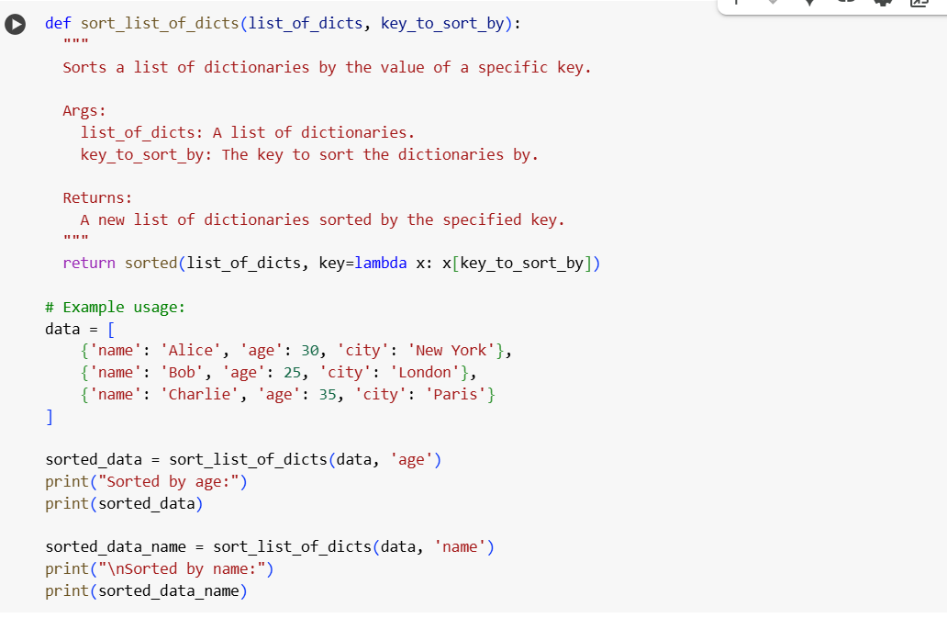

OUTPUT :

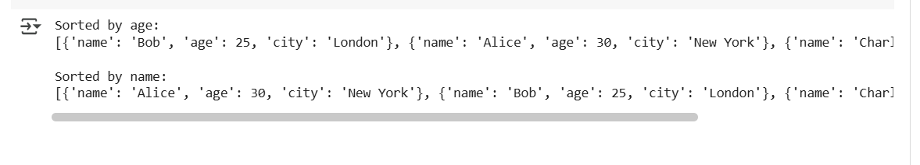

EXPLANATION :
